Page Layout Exercise 3-6: Design Page layout for the homepage of Learning Web Design

**The display original homepage index.html**

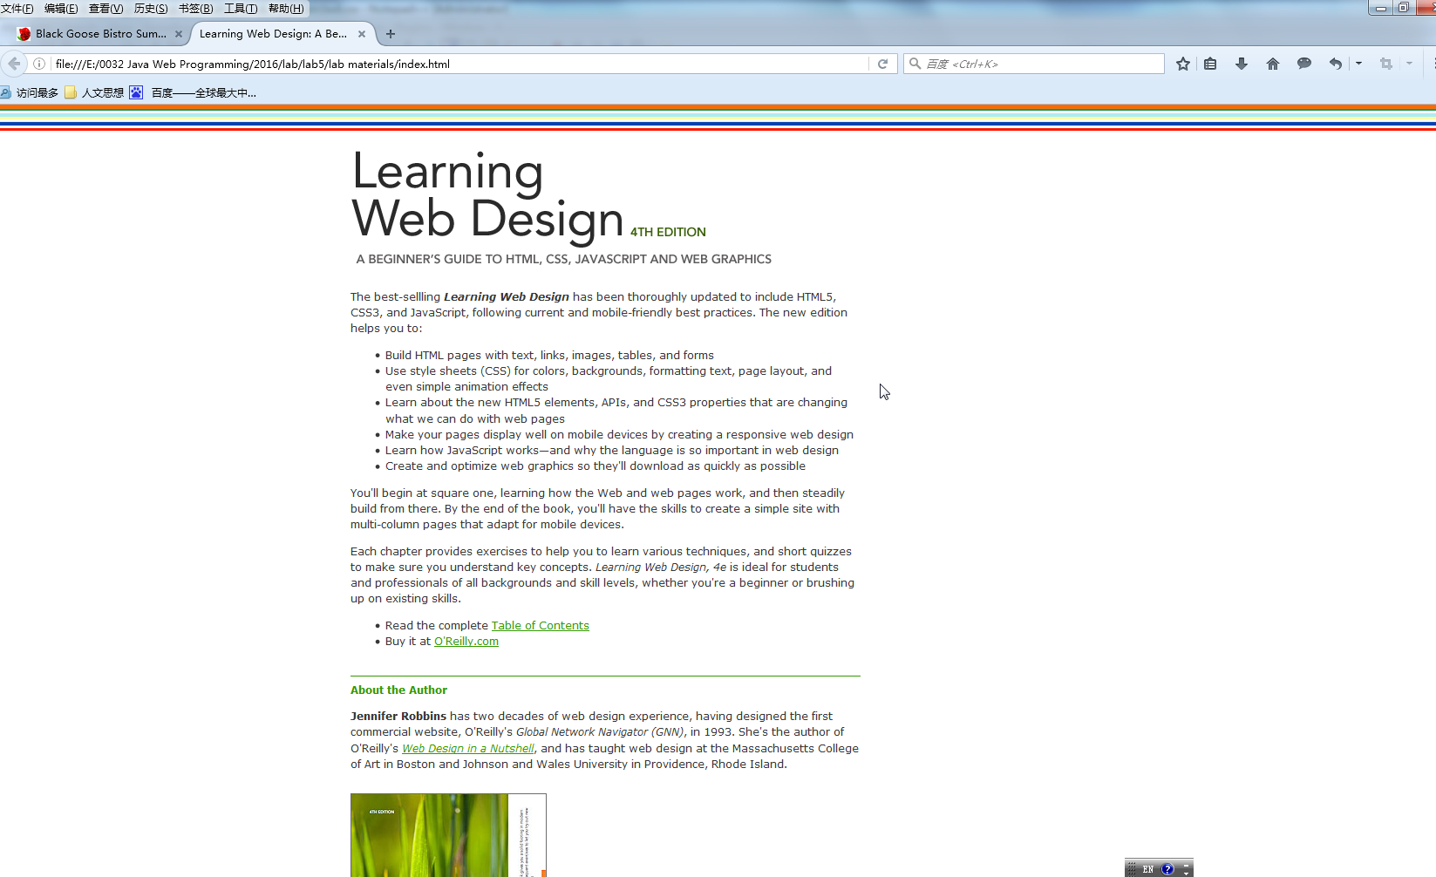

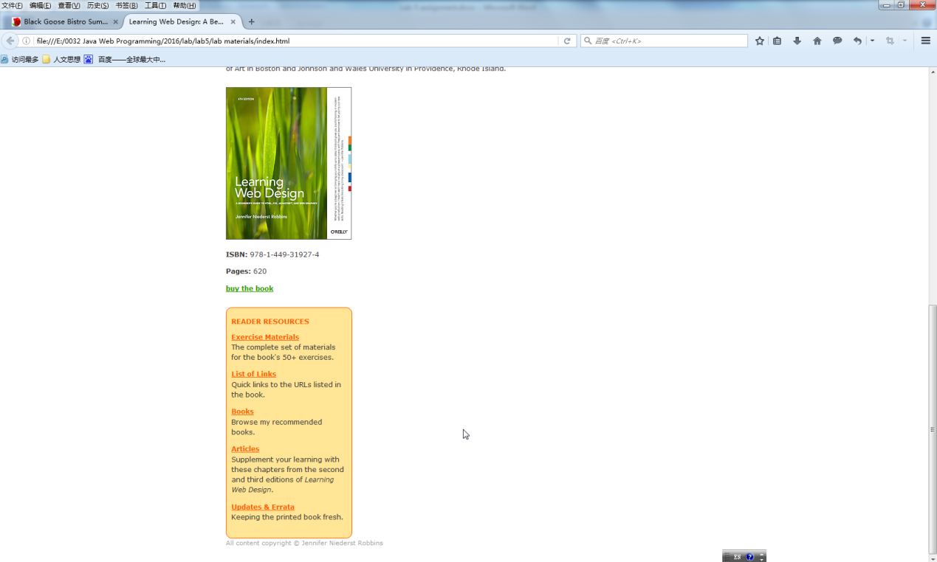

Please insert declarations into lwd.css

#container {

width: 850px;

/* write container margin layout declarations below */

margin:50px auto auto auto;

}

#main {

width: 585px;

/* write main layout declarations below */

}

#side {

/* write side layout declarations below */

}

### Exercise 3-6-1: make main on the left and side on the right using float

The lab result should be following display

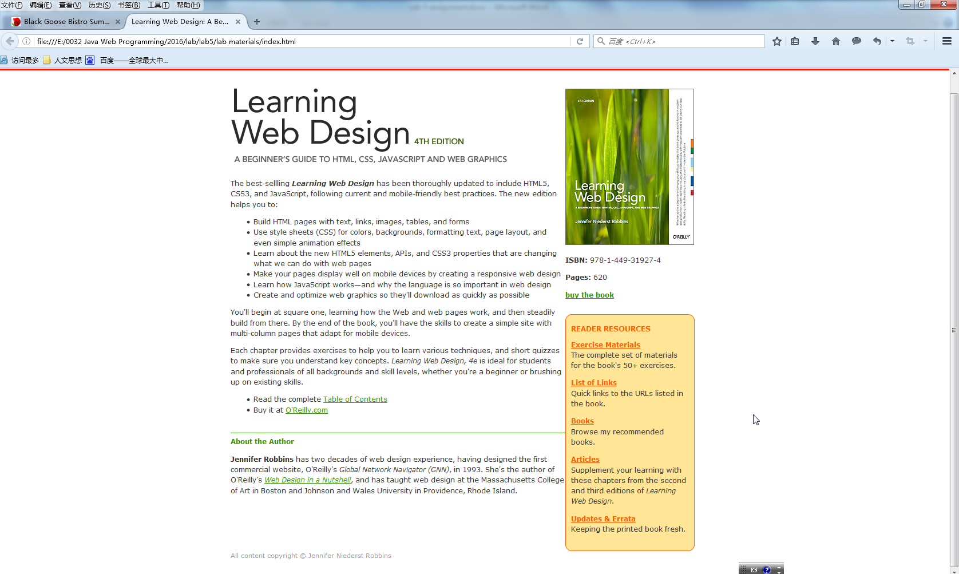

### Exercise 3-6-2: Rearrange the order to make main on the right and side on the left using float

